

Safegrid Grating
When you are involved in specifying, distributing, purchasing, fabricating, or installing steel
gratings, it is advised that you provide products that comply with the British and European
standards for ball proof requirements. Your commitment to ensuring site safety by using compliant products is essential to upholding industry standards.

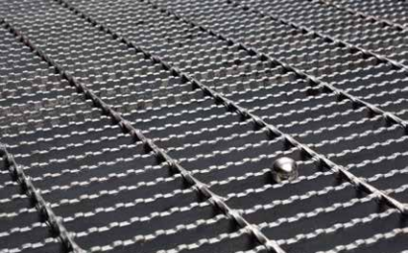
Safegrid 20 Ball Proof Grating Speciﬁcation to: BS4592-0:2006+A1:2012
Our 20mm ball proof grating covers a wide variety of applications and is EPD certiﬁed.
This product has been designed in line with British
Standard BS4592-1:2006 and European Standard BS EN ISO 14122-2-2016, in doing so we have ensured that it meets the ball proof requirements when used for access where a walkway or platform is in constant use, trafﬁc may pass beneath regularly and where
there are often people working below. 20mm ball-
proof ﬂooring must also be used for ﬁre escape stairs.

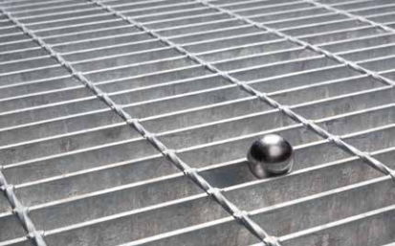

Safegrid 35 Ball Proof Grating Speciﬁcation to: BS4592-0:2006+A1:2012

Our 35mm ball proof grating will suit most applica- tions, is EPD certiﬁed and is a fully compliant
alternative to 41/100 (W).
This product has been designed to comply with
British Standard BS4592-1:2006 and European
Standard BS EN ISO 14122-2-2016, in doing so we have ensured that it meets the ball proof
requirements when used for access where a walkway or platform is in occasional use, trafﬁc may pass
beneath occasionally and where there are no people working below.
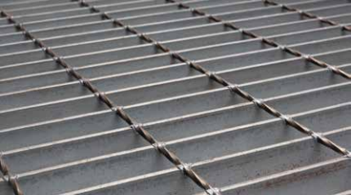
Safegrid Utility Grating Speciﬁcation to: BS4592-0:2006+A1:2012

Our Utility Grating product is the most efﬁcient and sustainable solution available on the market as it uses the least amount of steel.
This ﬂooring will suit most applications that do not
require a ball proof product, is compliant to current BS4592-1:2006 under the provision that no personnel can gain access underneath, and it is EPD certiﬁed.
This product has been designed in line with British Standard BS4592-1:2006 and European Standard BS EN ISO 14122-2-2016.

Email technical@lk-uk.com or call us on

+44(0) 1642 233 297 to find out more.
www.lk-uk.com


LIONWELD KENNEDY"
GROUP

Safegrid

Load Tables

3MM LK20BP (MESH SIZE 21/100) 5MM LK20BP (MESH SIZE - 23/100)

Self Colour Weights Per Square Metre (kgs)
Loading Category
Max Clear Span 4mm Deﬂection
Deﬂection (mm)
Bearing Bar Dimensions (mm)
Deﬂection (mm)
Max Clear Span L/200or 10mm Max Deﬂection
Binding Bar Weight Based on 2x1m (kgs)
Deﬂection (mm)
Deﬂection (mm)
Self Colour Weights Per Square Metre (kgs)
Binding Bar Weight Based on 2x1m (kgs)
Max Clear Span 4mm Deﬂection
Bearing Bar Dimensions (mm)
Loading Category
Max Clear Span L/200or 10mm Max Deﬂection
5kn/m2 1215 3.96 1400 6.98
25 x 5 45.01 1.96
7.5kn/m2 1105 3.95 1235 6.17
25 x 3
5kn/m2 985 3.98 1155 5.75
30.49 1.18
7.5kn/m2 985 3.98 1060 5.24
5kn/m2 1410 3.99 1700 8.43
30 x 5 53.45 2.36
7.5kn/m2 1280 3.94 1500 7.43
5kn/m2 1210 3.97 1470 7.28
36.03 1.41
7.5kn/m2 1145 3.93 1295 6.43
30 x 3
5kn/m2
1590
3.97
2000
9.93
5kn/m2 1430 3.99 1735 8.64
41.56
7.5kn/m2 1300 3.99 1530 7.65
1.65
35 x 5
61.89 2.75
35 x 3
1450
3.97
1770
8.82
7.5kn/m2
5kn/m2 1765 3.98 2220 9.96
40 x 5 70.33 3.14
7.5kn/m2 1610 3.97 2025 9.93
40 x 3
1.88
5kn/m2 1585 3.96 1995 9.93 47.09 7.5kn/m2 1445 3.99 1760 8.76

45 x 5
5kn/m2 1930 3.96 2430 9.96
78.77 3.53
7.5kn/m2 1765 3.98 2220 9.95
5kn/m2 2095 4.00 2630 9.93
87.21 3.93
7.5kn/m2 1915 3.99 2405 9.92
50 x 5
3.99
3015
9.94
2400
4.71
60 x 5 104.09 7.5kn/m2 2200 3.99 2765 9.96
5kn/m2

5MM LK35BP (MESH SIZE - 38/125)
3MM LK35BP (MESH SIZE - 37/125)
Bearing Bar | Loading | Max Clear  1170 4.00 1320 5.29 5kn/m2 1425 3.97 1730 8.63  25.33 1.65 35 x 5  1140 3.93 1290 6.45 7.5kn/m2 1295 3.97 1520 7.54 | Deﬂection | Max Clear Span | Deﬂection | Self Colour Weights | Binding Bar |  | Bearing Bar | Loading | Max Clear | Deﬂection | Max Clear Span | Deﬂection | Self Colour Weights | Binding Bar
Dimensions | Category | Span 4mm | (mm) | L/200or 10mm | (mm) | Per Square Metre | Weight Based |  | Dimensions | Category | Span 4mm | (mm) | L/200or 10mm | (mm) | Per Square Metre | Weight Based
(mm) |  | Deﬂection |  | Max Deﬂection |  | (kgs) | on 2x1m (kgs) |  | (mm) |  | Deﬂection |  | Max Deﬂection |  | (kgs) | on 2x1m (kgs)
5kn/m2 1050 4.00 1205 6.01
25 x 5 28.74 1.96
7.5kn/m2 985 3.96 1055 5.21
25 x 3
5kn/m2 800 3.96 805 4.02
18.74 1.18
7.5kn/m2 800 3.96 805 4.02
5kn/m2 1260 3.97 1465 7.26
30 x 5 34.04 2.36
7.5kn/m2 1145 3.98 1290 6.42
30 x 3
5kn/m2 985 3.99 1070 4.86
22.03 1.41
7.5kn/m2 985 3.99 1070 5.02

5kn/m2 7.5kn/m2
39.34 2.75
35 x 3
5kn/m2 1585 4.00 1990 9.93
40 x 5 44.64 3.14
7.5kn/m2 1440 3.98 1750 8.68
5kn/m2 1355 3.98 1585 5.72
28.63 1.88
7.5kn/m2 1270 3.96 1485 7.40
40 x 3
5kn/m2 1735 3.98 2180 9.92
49.94 3.53
7.5kn/m2 1580 3.99 1980 9.84
45 x 5
50 x 5
5kn/m2 1880 3.97 2365 9.93
55.24 3.93
7.5kn/m2 1715 3.99 2155 9.95

4.71
5kn/m2 2160 3.97 2720 9.98
60 x 5 65.84 7.5kn/m2 1970 3.97 2480 9.96

5MM
UTILITY GRATING (MESH SIZE - 47/125)
3MM UTILITY GRATING (MESH SIZE - 47/125)

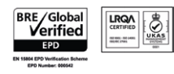
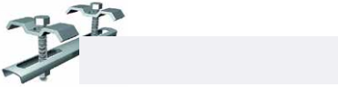
5kn/m2 960 3.95 1115 5.57
25 x 5 23.84 1.96
7.5kn/m2 935 3.95 985 4.86
1.18
25 x 3
5kn/m2 1180 3.97 1370 6.79
30 x 5 28.16 2.36
7.5kn/m2 1085 3.94 1205 6.00
30 x 3
5kn/m2
1355
3.97
1615
8.01
1.65
35 x 5
32.47 2.75
35 x 3
7.5kn/m2
1230
3.96
1420
7.04
5kn/m2 1650 3.96 2075 9.91
45 x 5 41.11 3.53
7.5kn/m2 1500 3.96 1855 9.27 5kn/m2 1790 3.96 2255 9.97
50 x 5 45.43 3.93 7.5kn/m2 1630 3.98 2050 9.95
5kn/m2 2060 3.98 2590 9.93
60 x 5 54.06 4.71 7.5kn/m2 1875 3.97 2360 9.96

PANEL JOINING CLIPS ARE REQUIRED IF L/200 OR 10MM DEFLECTION IS USED
Self Colour Weights Per Square Metre (kgs)
Loading Category
Max Clear Span 4mm Deﬂection
Deﬂection (mm)
Bearing Bar Dimensions (mm)
Deﬂection (mm)
Max Clear Span L/200or 10mm Max Deﬂection
Binding Bar Weight Based on 2x1m (kgs)
Deﬂection (mm)
Deﬂection (mm)
Self Colour Weights Per Square Metre (kgs)
Binding Bar Weight Based on 2x1m (kgs)
Max Clear Span 4mm Deﬂection
Max Clear Span L/200or 10mm Max Deﬂection
Bearing Bar Dimensions (mm)
Loading Category
5kn/m2 1065 3.97 1165 4.91
20.38
7.5kn/m2 1065 3.97 1165 5.47
5kn/m2 900 4.00 950 4.55
17.79 1.41
7.5kn/m2 900 4.00 950 4.55
5kn/m2 635 2.78 635 2.78
15.20
7.5kn/m2 635 2.78 635 2.78

40 x 3 | 5kn/m2 1235 3.97 1395 5.28  22.97  7.5kn/m2 1195 3.96 1370 6.83 | 1.88 | 40 x 5 | 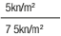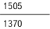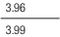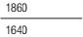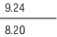 36.79 | 3.14

Notes
1. Deflection in the table above is limited to span/200 or 10mm, whichever is the lesser.
2. It should be noted that the difference in level between a loaded and a neighbouring
unloaded flooring shall not exceed 4mm. LK panel joint clips can be used to negate this issue. The tables have both options listed.
3. The tables are based upon BS4592-0:2006+A1:2012 & BS5950-1:2000 .
4. The tables take into consideration MINIMUM bearing bar rolling tolerances as defined by LKFS-STD-98 .
5. Material is BS EN 10025 Grade S275JR
Email technical@lk-uk.com or call us on
+44(0) 1642 233 297 to find out more.

